
IOT
PROJECT REPORT
Smart Fire Alarm and Extinguishing System

DONE BY-
Simran Kapoor(2430197)
Sharanya Singh(2430191)
CONTENTS

- INTRODUCTION

- THEORY AND COMPONENTS

3.DATA TRANSFER, FIREBASE CONFIGURATION, WEBSITE INTEGRATION,

4.WORKING PRINCIPLE

5.PROCEDURE

6.OUTPUT

7.PRECAUTIONS

8.CONCLUSION

9.BIBLIOGRAPHY

Introduction

Fire safety is a vital aspect of modern infrastructure, especially in densely populated urban areas, industrial zones, and residential complexes. Traditional fire detection systems typically rely on manual alarms or standalone smoke detectors, which may not provide real-time alerts or automated responses. These systems often lack integration with modern communication platforms, making them less effective in emergency scenarios.
This project proposes a smart fire extinguisher system built on the principles of the Internet of Things (IoT). It leverages a network of sensors—flame, smoke, and temperature—connected to an ESP microcontroller. The system is designed to detect fire indicators, activate a relay-controlled extinguisher, and send real-time temperature data to Firebase, a cloud-based database. A mobile application developed using Kodular provides instant notifications and displays sensor readings, enabling remote monitoring and control.
The goal is to create a low-cost, scalable, and responsive fire safety solution that can be deployed in homes, offices, and industrial settings. This system not only enhances safety but also demonstrates the power of IoT in critical applications.

Theory and Components
🔍 Overview of IoT in Fire Safety
IoT enables the interconnection of physical devices through the internet, allowing them to collect and exchange data. In fire safety, IoT can be used to:
- Detect fire indicators in real-time.
- Trigger automated suppression systems.
- Notify users remotely via mobile or cloud platforms.
- Log environmental data for analysis and auditing.
🔧 Component Breakdown
1. Flame Sensor
- Type: Infrared flame sensor module.
- Detection Range: 760–1100 nm wavelength.
- Output: Digital (HIGH when flame is detected).
- Use Case: Detects open flames such as candles, matches, or fire outbreaks.
- Sensitivity: Adjustable via onboard potentiometer.
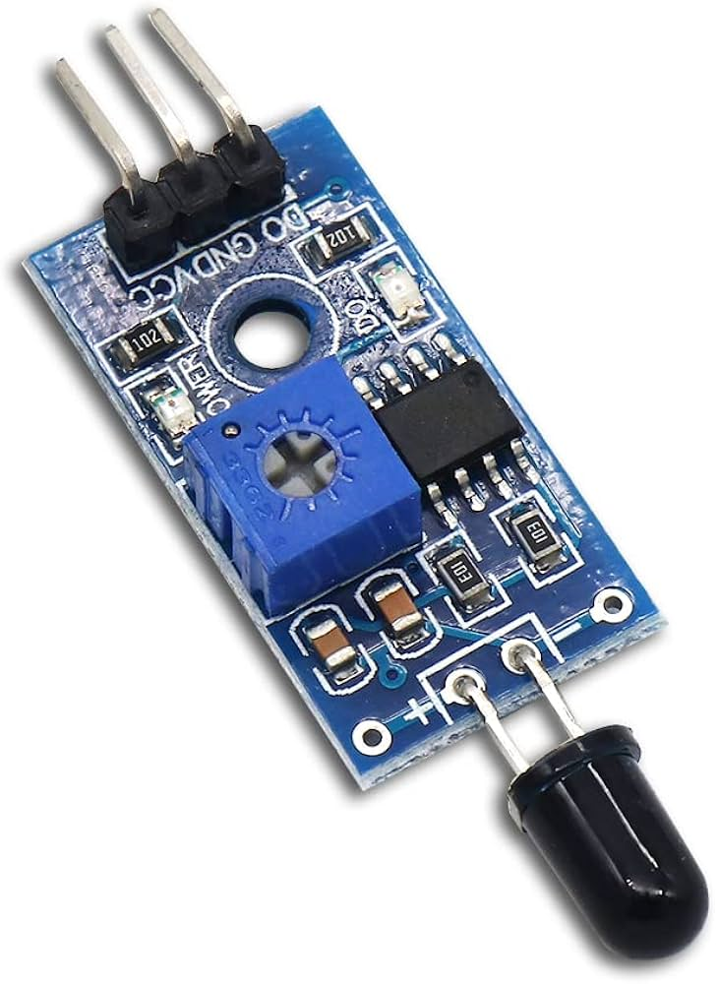
2. Smoke Sensor (MQ-2 or MQ-135)
- Type: Gas sensor module.
- Detection Range: LPG, methane, carbon monoxide, smoke.
- Output: Analog signal (varies with gas concentration).
- Use Case: Detects smoke from smoldering fires or gas leaks.
- Calibration: Requires preheating and threshold tuning.
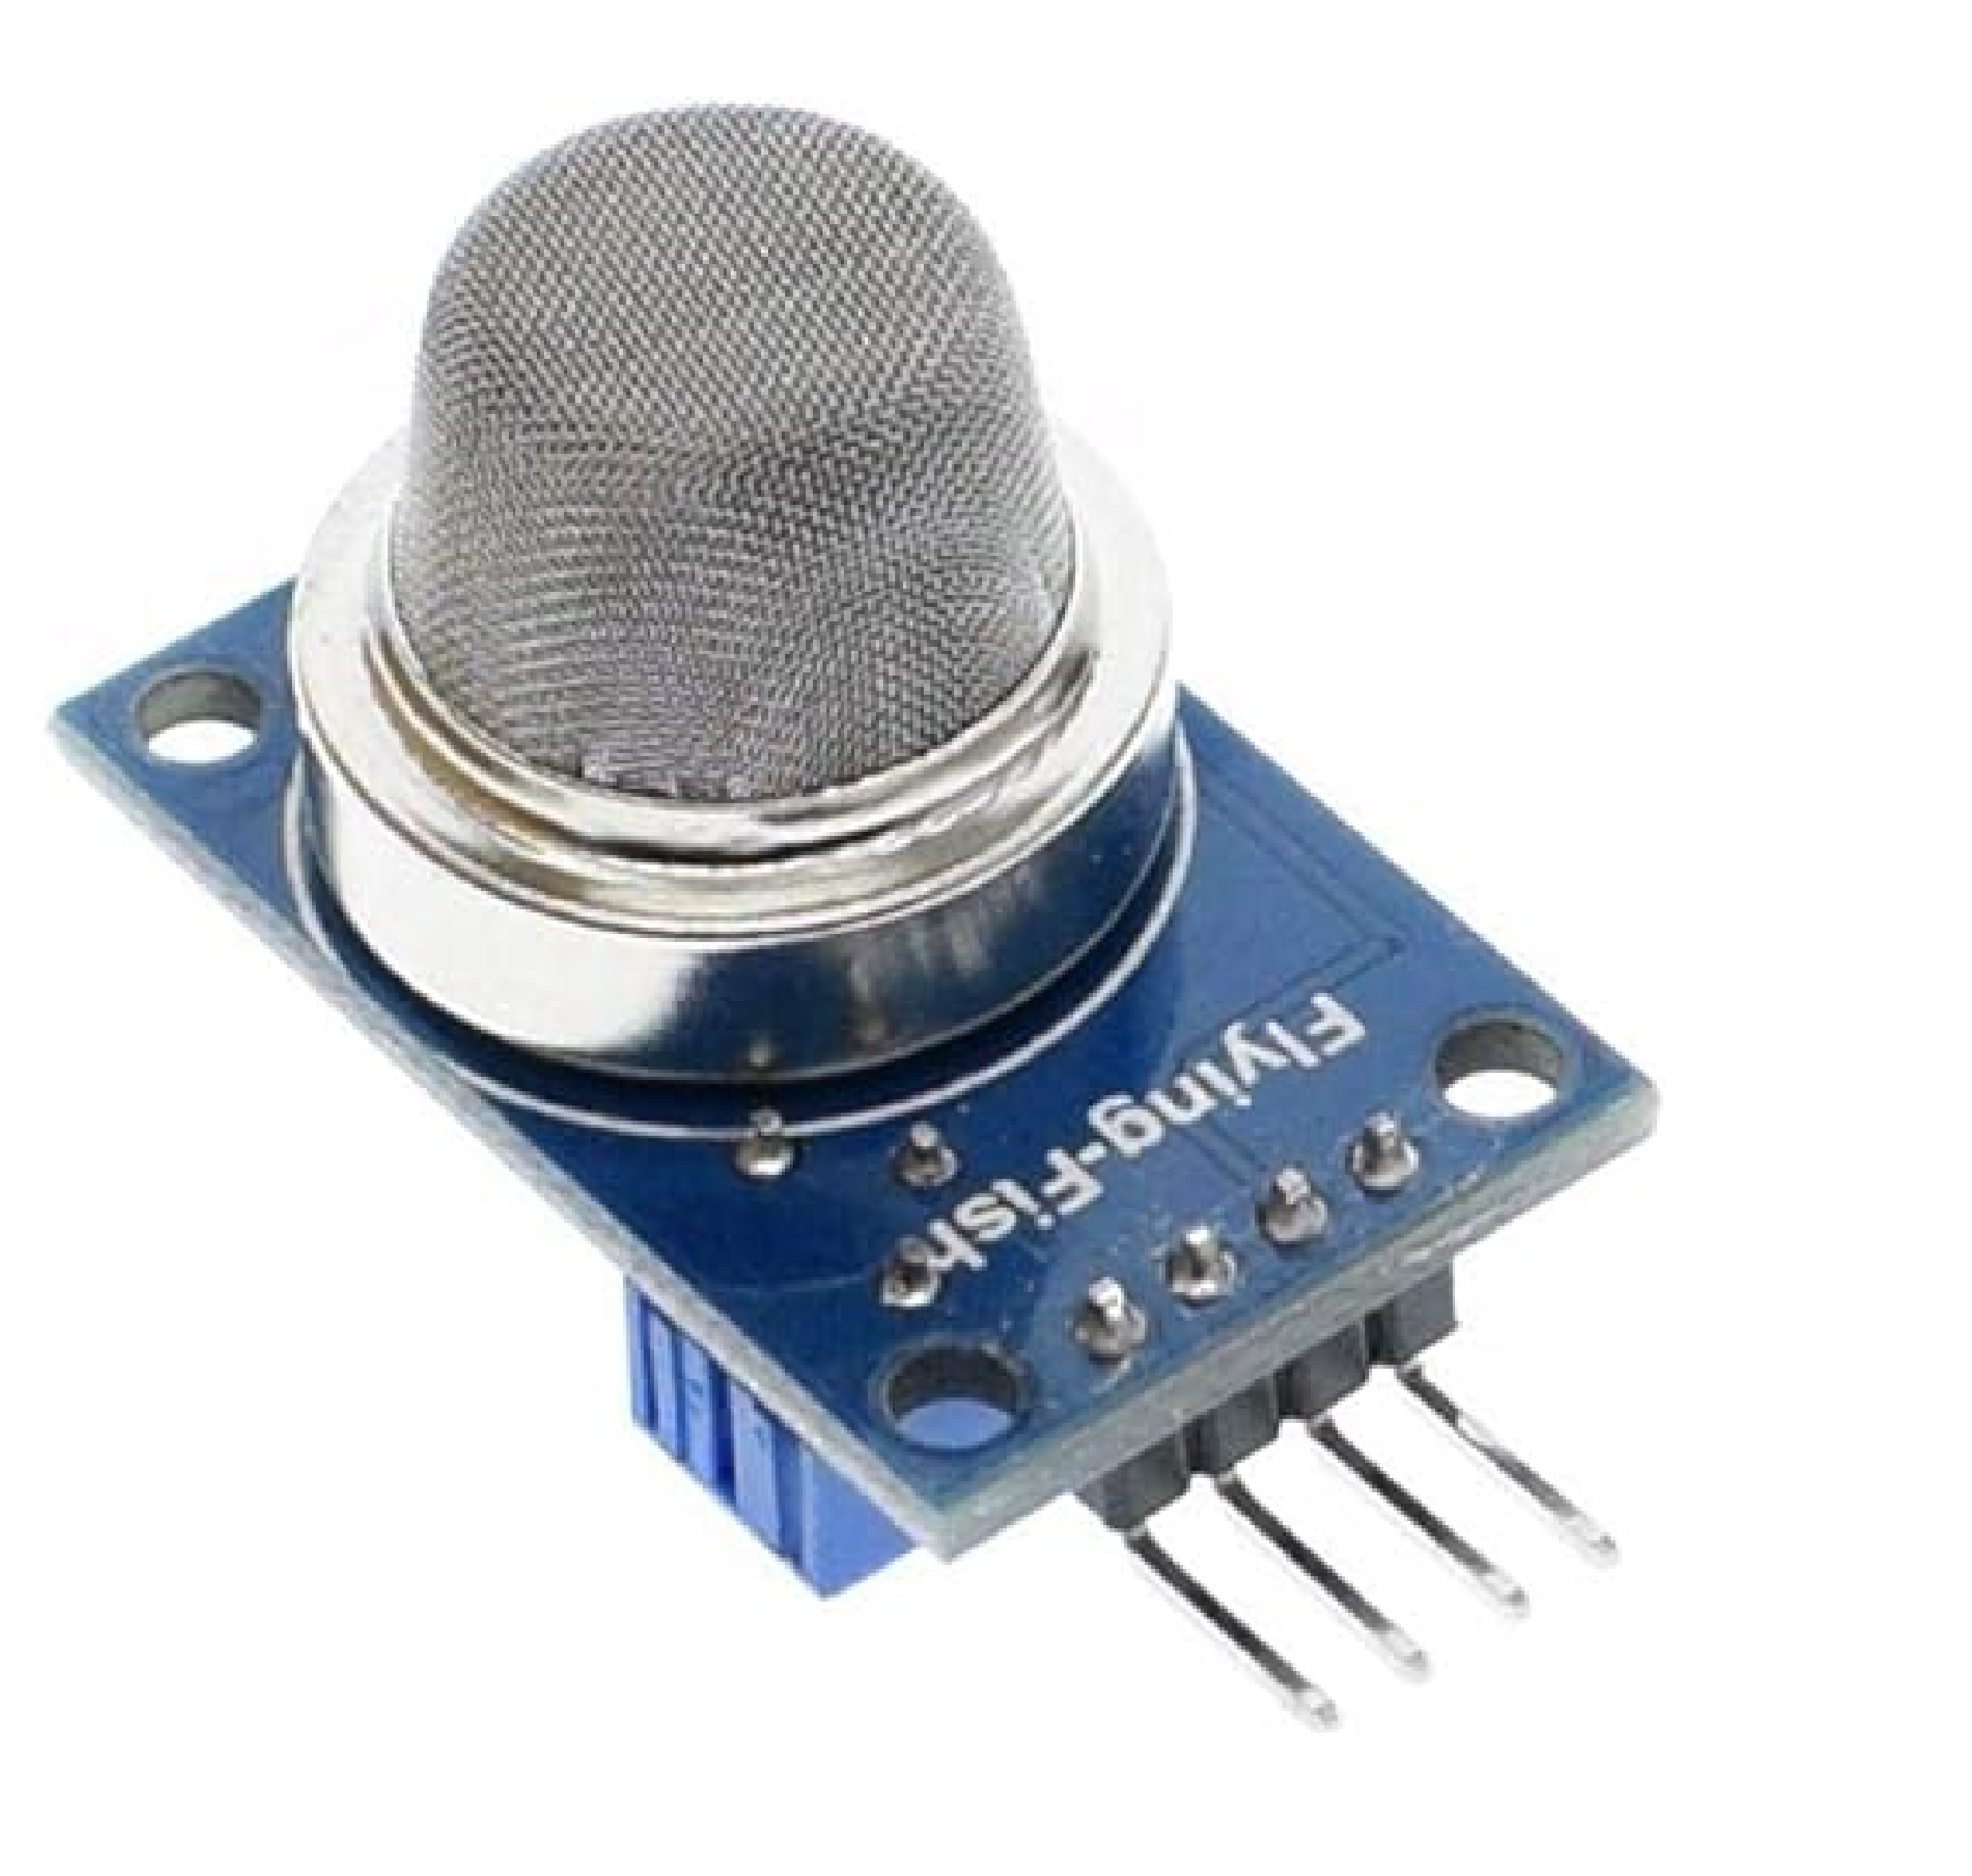
3. Temperature Sensor (DHT11 or LM35)
- Type: Digital (DHT11) or analog (LM35).
- Range: DHT11: 0–50°C; LM35: -55°C to 150°C.
- Accuracy: ±2°C (DHT11); ±0.5°C (LM35).
- Use Case: Monitors ambient temperature and sends readings to Firebase.
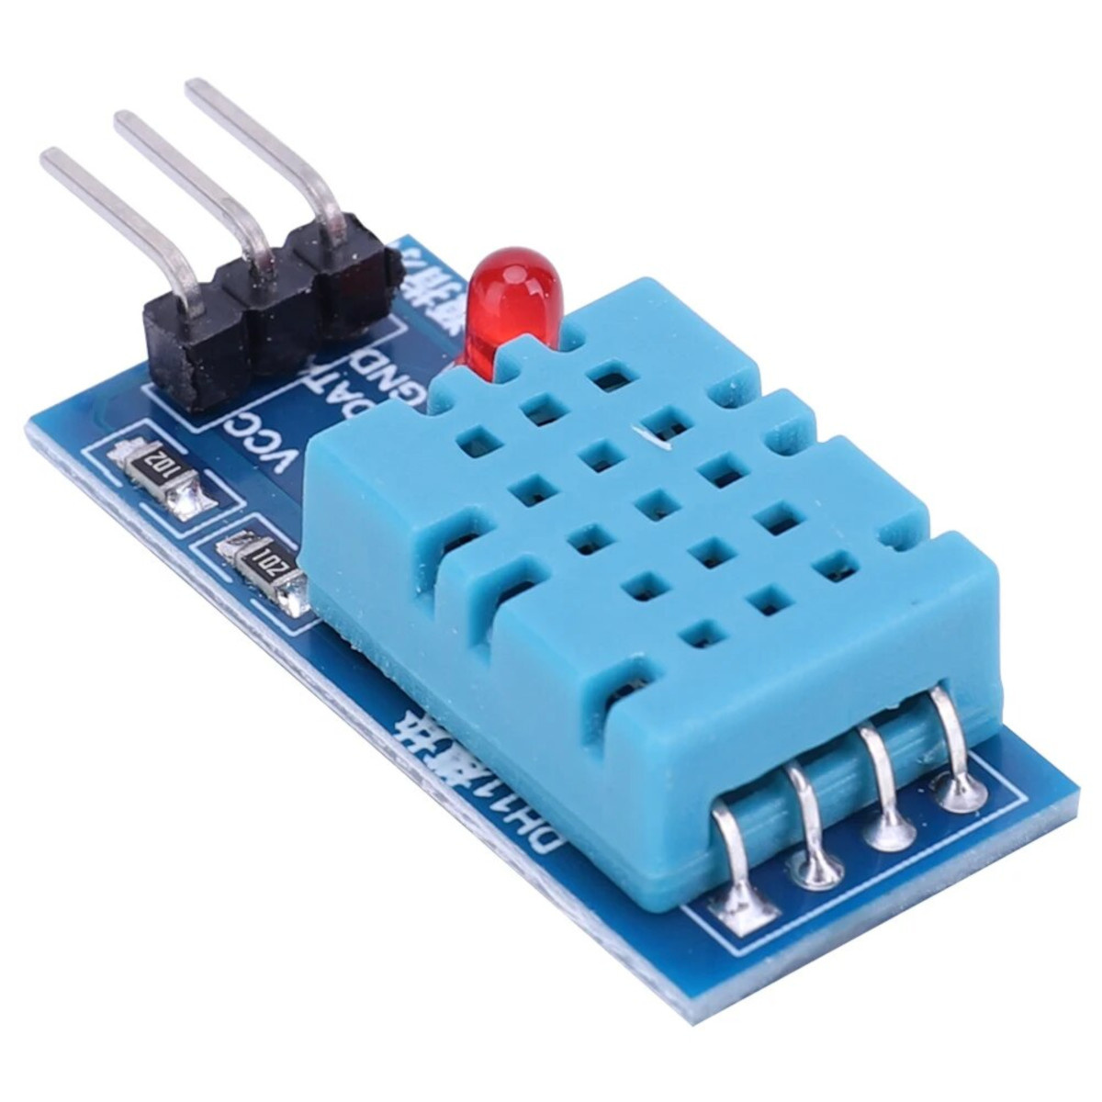

4. Relay Module
- Type: 1-channel or 2-channel relay.
- Voltage: 5V or 12V control signal.
- Use Case: Controls fire extinguisher mechanism or alarm system.
- Isolation: Opto-isolated for safety.
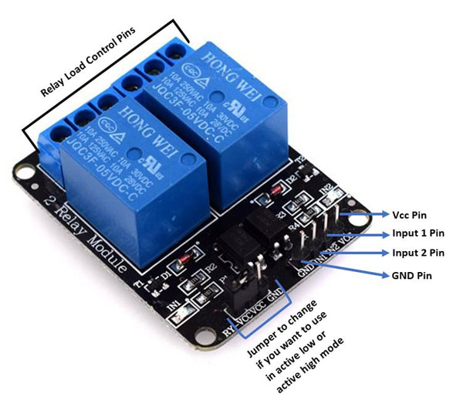

5. ESP Board (ESP8266 or ESP32)
- Features:
  - Wi-Fi connectivity.
  - GPIO pins for sensor input/output.
  - Low power consumption.
  - Compact form factor.
- Use Case: Central processing unit for sensor data and cloud communication.
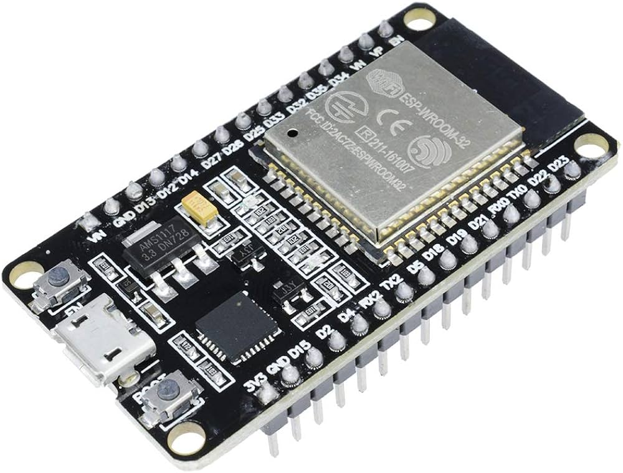

6. Firebase
- Type: Real-time cloud database.
- Features:
  - REST API integration.
  - Real-time data sync.
  - Secure access control.
- Use Case: Stores temperature readings and fire status flags.
7. Kodular
- Type: No-code Android app builder.
- Features:
  - Firebase integration blocks.
  - Push notification components.
  - Custom UI design.
- Use Case: Displays sensor data and sends alerts to users.

🔶 Project Section: Data Transfer, Firebase Configuration, and Website Integration

1. Data Transfer from Arduino to ESP Board (Hardware Communication:
Purpose:
The Arduino board collected data from various sensors — the flame sensor, smoke sensor, and temperature sensor — and this data needed to be sent wirelessly to the internet. The ESP board (ESP8266/ESP32) was used as a Wi-Fi module to make this communication possible.
Connection Setup:
The Arduino was connected to the ESP board through serial communication pins (TX and RX).
Arduino’s TX pin (transmit) was connected to the RX pin (receive) of the ESP board, and RX of Arduino to TX of ESP, with a common ground shared between them.
Since Arduino operates on 5V logic and ESP on 3.3V, a voltage divider or level shifter was used to safely connect the two.
The ESP board was powered by a stable 3.3V supply, either from an external regulator or from a NodeMCU/ESP32 board.
Working Principle:
The Arduino continuously read sensor values and sent them serially to the ESP module.
The ESP acted as a Wi-Fi bridge, receiving these sensor readings and uploading them to the Firebase Realtime Database.
This allowed all sensor data to be stored and updated in real time on a cloud server.
Why this was done:
The Arduino itself does not have Wi-Fi capability, so the ESP handled the networking and cloud communication.
This separation of tasks improved efficiency — Arduino handled sensing and control, while ESP handled data transmission.

2. Configuring and Connecting Firebase to Arduino IDE (Realtime Data Storage)
Creating the Firebase Project:
A new project was created on the Firebase Console.
Inside this project, a Realtime Database was created to store live sensor data.
The database URL (example: https://project-id-default-rtdb.firebaseio.com/) was noted down.
Setting Database Rules:
For testing, the read/write permissions were temporarily set to true so that the ESP could freely send and receive data.
Later, authentication can be added to improve security.
Adding Device Credentials:
The Wi-Fi credentials (SSID and password) and Firebase database link were configured in the Arduino IDE.
The ESP board was connected to Wi-Fi automatically when powered on.
Library and Board Setup in Arduino IDE:
The ESP8266 (or ESP32) board package was installed through the Boards Manager.
The Firebase library (such as “FirebaseESP8266” or “FirebaseESP32”) was installed to handle cloud communication easily.
Data Upload Process:
The ESP board connected to the internet using the Wi-Fi credentials.
It then connected to the Firebase database using the project URL and authentication key (or open access in test mode).
The ESP sent the sensor data received from Arduino to Firebase as individual data fields like temperature, smoke level, flame detected, and relay status.
Each time new data was uploaded, Firebase automatically updated its records, maintaining a live data feed.
Verifying Data on Firebase Dashboard:
On the Firebase Console, the Realtime Database tab displayed the data structure.
As the sensors changed, the values updated live without needing to refresh the page.
This verified that the ESP and Firebase connection worked correctly.

3. Dashboard Creation and Realtime Visualization
Realtime Database View:
Firebase provided a built-in view showing the live values updating in real time.
The database entries appeared in a tree-like structure where each sensor’s value was stored under a defined node (for example, /temperature, /smoke, /flame).
Custom Web Dashboard Requirement:
To make the project more interactive, a custom HTML webpage was created that fetched data directly from the Firebase database.
The aim was to view real-time sensor values on any device (phone or computer) without opening the Firebase console.

4. Transferring Firebase Data to the HTML Website (Realtime Display)
Connecting Firebase to the Web:
Inside the Firebase Console, a Web App was added under the same project.
This generated a unique configuration snippet (containing API key, project ID, and database URL).
These credentials were linked inside the HTML file to allow the webpage to connect securely to the Firebase project.
Setting Up the Webpage Structure:
The HTML page was designed to show live sensor values (temperature, smoke level, flame detection, and relay state).
It was made simple, responsive, and readable for demonstration purposes.
Realtime Synchronization:
The webpage was programmed to listen to changes in the Firebase Realtime Database.
Whenever a new sensor reading was uploaded by the ESP, the Firebase SDK automatically sent the updated data to the webpage.
This created a continuous, real-time dashboard where the user could see the latest readings instantly — without refreshing the page.
Demonstration Flow:
The sensors detected environmental changes (like smoke or fire).
The Arduino read the sensor values and sent them to the ESP.

The ESP uploaded these readings to Firebase.
The HTML page fetched these values live and displayed them instantly.
In case of a fire, the page could show alerts such as “Flame Detected!” or “Smoke Level High!” in real time.

5. Testing and Final Integration
Testing Steps:
Each sensor was tested individually to confirm it was reading correctly.
The Arduino–ESP serial connection was checked to ensure proper data transfer.
Firebase was monitored for real-time updates as the sensors changed.
The web dashboard was opened to verify that changes appeared instantly.
Result:
The data flow from physical sensors → Arduino → ESP → Firebase → Website worked seamlessly.
The system successfully created a live IoT monitoring and control environment.
Outcome:
The project achieved full automation and cloud connectivity, making it a complete IoT-based smart fire detection and extinguishing system with real-time monitoring and alerts.

6. Advantages of This Setup
Cloud-based Real-time Updates: All sensor data stored on Firebase, accessible from anywhere.
Web Visualization: Easy monitoring without specialized apps.
Scalability: More sensors or devices can be added later using the same Firebase structure.
Low Cost & Reliable: Uses open-source tools and free Firebase tier.
Efficient Communication: Arduino focuses on sensor control; ESP handles networking.

Working Principle
The system operates in a continuous loop, monitoring environmental conditions through its sensors. Here's how each component interacts:
- Detection Phase:
  - Flame sensor detects infrared light from fire.
  - Smoke sensor measures gas concentration.
  - Temperature sensor reads ambient temperature.
- Decision Phase:
  - ESP board processes sensor data.
  - If flame or smoke exceeds threshold, it triggers the relay.
- Action Phase:
  - Relay activates fire extinguisher or alarm.
  - Temperature data is sent to Firebase.
- Notification Phase:
- Firebase updates are fetched by Kodular app.
- App sends push notification to user.
- Temperature readings are displayed on mobile interface.
This multi-tiered approach ensures early detection, automated response, and remote awareness.

Procedure
1. Hardware Assembly
- Connect flame sensor to digital pin D1.
- Connect smoke sensor to analog pin A0.
- Connect temperature sensor to D2 (DHT11) or A1 (LM35).
- Connect relay module to digital pin D3.
- Connect fire extinguisher or buzzer to relay output.
- Power ESP board via USB or external adapter.
2. Software Development
- Use Arduino IDE to write ESP firmware.
- Include libraries:
  - ESP8266WiFi.h
  - FirebaseESP8266.h
  - DHT.h
- Define Wi-Fi credentials and Firebase URL.
- Set sensor thresholds:
  - Flame: HIGH = fire.
  - Smoke: analog > 300 = smoke.
  - Temperature: read and send every 10 seconds.
- Logic flow:
- If flame or smoke detected → activate relay.
- Send temperature to Firebase.
- Update fire status flags.
3. Firebase Configuration
- Create Firebase project.
- Set up real-time database with nodes:
  - /temperature
  - /flame_status
  - /smoke_status
- Enable read/write permissions.
4. Testing and Validation
- Simulate fire using lighter or incense.
- Observe sensor response and relay activation.
- Check Firebase for temperature updates.
- Verify mobile notifications.

Output
The system delivers the following outputs:
- Sensor Detection:
  - Flame sensor: digital HIGH.
  - Smoke sensor: analog > threshold.
  - Temperature sensor: real-time value.
- Relay Activation:
  - Relay switches ON to activate extinguisher or buzzer.
- Cloud Logging:
  - Firebase stores temperature and fire status.
- Mobile Alerts:
- Kodular app sends push notification.
- Displays temperature and fire status.

Precautions
- Sensor Calibration: Calibrate smoke sensor for accurate detection.
- Safe Testing: Use controlled flame sources.
- Power Supply: Use regulated power to avoid false triggers.
- Threshold Tuning: Adjust sensor thresholds to prevent false alarms.
- Secure Wiring: Insulate connections to prevent short circuits.
- Cloud Security: Protect Firebase credentials and restrict access.

Conclusion
This IoT-based fire extinguisher system exemplifies the integration of hardware and cloud technologies for real-time safety applications. It offers a proactive approach to fire detection and suppression, combining sensor intelligence with automated response and remote monitoring.
The ESP microcontroller serves as a compact and efficient processing unit, while Firebase ensures reliable data storage and synchronization. Kodular enhances user interaction by providing a customizable mobile interface. The system is scalable, cost-effective, and adaptable to various environments.
Future enhancements could include:
- GPS tracking for location-based alerts.
- SMS or email notifications.
- Integration with smart home platforms.
- AI-based anomaly detection.
This project not only improves fire safety but also showcases the transformative potential of IoT in life-critical systems.

Bibliography

- IoT Fire Detection using ESP32 and Flame Sensor
- Automatic Fire Extinguisher IoT Project – GitHub
- IoT-Based Smoke and Flame Detector – Saranathan College
- Firebase Documentation
- Kodular Community
- ESP8266 Arduino Core

